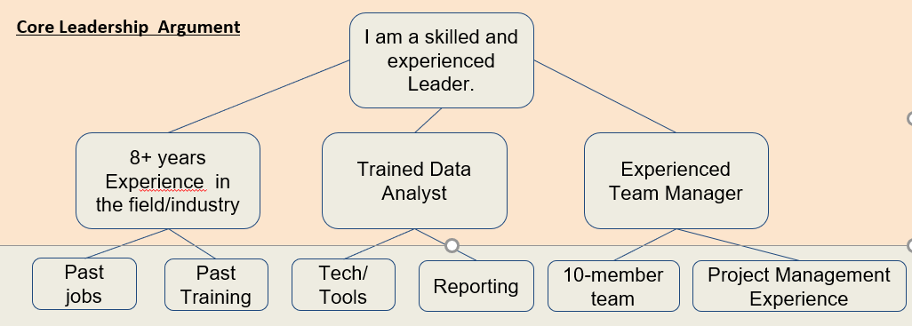

Let's break it down
I am a skilled leader - the argument - This should positively indicate you have mastered this skill
eight years of experience in markets - the reason
technology, .- support
customer service, and retail.- support
leadership training series from the CWU Center for Leadership - the reason
tools for using technologies such as MS Teams - support
MS Access software for team connections and data reporting. - support
recent position has given me experience
as the leader of a ten-member orientation team. -the reason
I led the team in developing programming for incoming students- support
utilized all team members' strengths and interests. - support
As a written statement what might the information above look like, assume the prompt at an interview was, "Tell us about your leadership skills."

I am a skilled leader with eight years of experience in markets such as technology, customer service, and retail. The leadership training series from the CWU Center for Leadership has given the tools for using technologies such as MS Teams and MS Access software for team connections and data reporting. My most recent position has given me experience as the leader of a ten-member orientation team. In that position, I led the team in developing programming for incoming students which best utilized all team members' strengths and interests.

- 88 words

Use this worksheet to develop your elevator speech about Critical Thinking
I am skilled
Critical Thinker

Click here to add Reasons

Click here to add Reasons

Click here to add Reasons

Click here to add Supports

Click here to add Supports

Click here to add Supports

I am skilled Critical Thinker - the argument - This should positively indicate you have mastered this skill
Flesh out your reason here - the reason
Flesh out your supports here. - support
Flesh out your supports. - support
Flesh out your reason here - the reason
Flesh out your supports here. - support
Flesh out your supports here. - support
Flesh out your reason here -the reason
Flesh out your supports.here - support
Flesh out your supports here. - support

Now make it into a paragraph with proper sentences here to complete the assignment

